AI Consultants

Valuation of Sports Bikes

Start Date: 1/6/19

|  |  |
| --- | --- |
| **Epic** | Bike Valuation |
| **Project status** | (Requirements, **Development**, Testing, Complete, On Hold) |
| **Client** | External (Sales manager of bike sales) |
| **Project owner** | Beau |
| **Developers** | Beau |
| **Stakeholders** | Buyers, Sellers, Sales Manager |
| **Design complete** | 1/7/19 |
| **Code complete** | 1/8/19 |
| **Testing complete** | 21/8/19 |
| **Release date** | 29/8/19 |

## Background

Bikesales is a company based in Melbourne operating completely online. Bikesales.com provides services for buyers and sellers of bikes. They charge fees to advertise bikes. The value of the bike is provided by the seller.

Customer experience can be improved by providing accurate valuation suggestions. The customer will then have an accurate valuation of the bike available for them to make an informed decision. This will increase the number of bikes for sale from both dealers and private sellers resulting in increased revenue.

## Objectives

|  |  |
| --- | --- |
| **Objective** | **Metric** |
| Increase the number of bikes for sale | The monthly inventory will increase |
| Reduce the time bikes are advertised for | The period each bike is advertised is reduced |
| Increase the ratio of bikes for sale to bikes sold | The ratio will increase from current value |

## Assumptions

* The dealers only advertise 50% of their stock
* Assumed ratio of advertising tiers (Ultimate: 10%, Premium 20%, standard 70%)
* Dealers have an accurate valuation of the bike
* Private sellers don’t know what the value of the bike really is.
* Proof of concept will focus on Sports Bikes.

## User Stories & Requirements

|  |  |  |  |  |
| --- | --- | --- | --- | --- |
| **Ref#** | **Name** | **User Story** | **Functional Requirements** | **Notes** |
| 1 | Seller valuation | As a seller, I want to know the true value of my bike, so I can sell my bike faster. |  |  |
| 2 | Buyer valuation | As a buyer, I want to know the value of the bike so I don’t pay too much. |  |  |
| 3 | Dealer sales | As a dealer, I want to sell bikes faster so I can make more revenue by having stock rotate faster. |  |  |

## Open Questions

|  |  |  |
| --- | --- | --- |
| **Question** | **Answer** | **Date Answered** |
| Should the method of valuation be publicly available? |  |  |
| How will buyers and sellers be made aware of this feature | The feature will be announced on the website and with a brief blog post.  There will be a valuation link on each advertisement. | 20/7/19 |

## Out of Scope

* Can this be applied to the full stock list?
* Can bikesales apply this to its other network sites (carsales, boatsales)?

## Risks

|  |  |  |  |
| --- | --- | --- | --- |
| **Risk** | **Likelihood** | **Impact** | **Mitigation** |
| Unable to access relevant data | Low | High | Regular interaction with IT staff will ensure access to available data.  Data can be automatically obtained from website if required. |
| Unable to obtain sufficient amount of data | Low | High | Bikesales maintains a database of existing and previous customers using the site. |
| The accuracy of the valuation is insufficient | Medium | Medium | Regular monitoring of the valuation results, and regular auditing of randomly selected items with professional valuation. |
| Sellers wont advertise with us if they believe the valuation is low | Medium | High | Regular open communication of results using a blog.  Regular communication with leading dealers to answer any concerns. |
| Dealers may conspire together to increase the valuations predicted to artificially increase the sale prices | Low | Medium | Regular monitoring and validation of the model will allow analysts to identify a dramatic increase in valuations |

## 

## User Interaction and Design

### Design Model

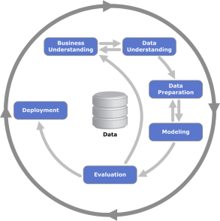

### Pipeline Model

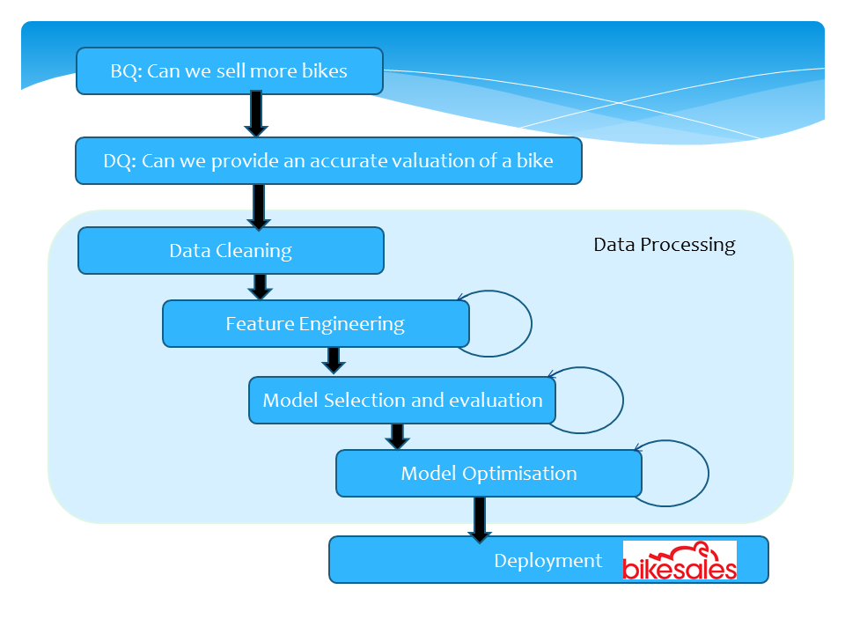

## Tasks

|  |  |  |
| --- | --- | --- |
| **Task** | **Owner** | **Due Date** |
| Acquire data | Beau | 1/6/19 |
| Data cleaning/processing | Beau | 1/7/19 |
| Feature engineering | Beau | 28/7/19 |
| Initial model development | Beau | 1/8/19 |
| Iterative model improvements | Beau | 15/8/19 |
| Testing and validation | Beau | 21/8/19 |
| Handover to bikesales | Beau | 29/8/19 |

## Results and Conclusions

1. The model
   1. A highly accurate valuation model has been produced for sports bikes.
   2. This modelled valuation will be within 5% of a professional valuation providing customers with additional information on the bike value. This also provides confidence for both the seller and buyer that the valuation is fair.
2. Improved customer experience
   1. This confidence in the market will likely lead to improved customer experience, driving dealers to advertise more stock on the site. Buyers will have more confidence in the value and be able to make decisions quicker.
   2. These will combine to increase the number of stock available on the website and reduce the time each bike spends on the site, increasing the ratio of bikes sold, to for sale.
3. Next steps
   1. The next step will be to put the model in to production and evaluate the effectiveness.
   2. We can also evaluate the accuracy of the model using professional valuation.
   3. AI Consulting can assist in these steps if required.
4. Recommendations
   1. We have evaluated multiple models including the state of the art neural networks. We found a highly accurate model based on all available features of each sport bike.
   2. We recommend using the provided model to predict a valuation of a bike to present to customers.